|  |  |
| --- | --- |
| **NAME** | V.VISHNU |
| **REG. NO.** | 420121106060 |
| **DEPARTMENT** | ECE |
| **YEAR** | III |
| **COLLEGE NAME** | AKTMCET |
| **GROUP** | IBM GROUP-2 |

**AQM- AIR QUALITY MONITORING**

**PHASE-1**

**Phase 1: Problem Definition and Design Thinking**

In this part you will need to understand the problem statement and create a document on what have you understood and how will you proceed ahead with solving the problem. Please think on a design and present in form of a document.

**Project Definition:**

The project involves setting up IoT devices to measure air quality parameters and make the data publicly available for raising awareness about air quality and its impact on public health. The objective is to create a platform that provides real-time air quality information to the public. This project includes defining objectives, designing the IoT monitoring system, developing the data-sharing platform, and integrating them using IoT technology and Python.

**Design Thinking:**

1. **Project Objectives:** Define specific objectives such as real-time air quality monitoring, data sharing, public awareness, and health impact.
2. **IOT Devices Designs:** Plan the design and deployment of IoT devices (sensors) to measure air quality parameters.
3. **Data Sharing Platform:** Design a web-based platform to display real-time air quality data to the public.
4. **Integration Approach:** Determine how IoT devices will send data to the data-sharing platform.

**Module 1:** Introduction to Internet of Things (IoT)

# What Is IoT:

IoT stands for Internet of Things. It refers to the interconnectedness of physical devices, such as appliances and vehicles, that are embedded with software, sensors, and connectivity which enables these objects to connect and exchange data. This technology allows for the collection and sharing of data from a vast network of devices, creating opportunities for more efficient and automated systems.

**Internet of Things (IoT)** is the networking of physical objects that contain electronics embedded within their architecture in order to communicate and sense interactions amongst each other or with respect to the external environment. In the upcoming years, IoT-based technology will offer advanced levels of services and practically change the way people lead their daily lives. Advancements in medicine, power, gene therapies, agriculture, smart cities, and smart homes are just a very few of the categorical examples where IoT is strongly established.

# Different types of Sensors:

* Temperature Sensors
* Image Sensors
* Gyro Sensors
* Obstacle Sensors
* RF Sensor
* IR Sensor
* MQ-02/05 Gas Sensor
* LDR Sensor
* Ultrasonic Distance Sensor

# IoT Enablers:

* **RFIDs:** uses radio waves in order to electronically track the tags attached to each physical object.
* **Sensors:** devices that are able to detect changes in an environment (ex: motion detectors).
* **Nanotechnology:** as the name suggests, these are tiny devices with dimensions usually less than a hundred nanometers.
* **Smart networks:** (ex: mesh topology).

# Working of IoT

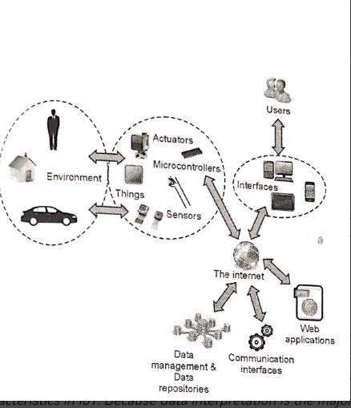

**Characteristics of IoT:**

* Massively scalable and efficient
* IP-based addressing will no longer be suitable in the upcoming future.
* An abundance of physical objects is present that do not use IP, so IoT is made possible.
* Devices typically consume less power. When not in use, they should be automatically programmed to sleep.

**Module 2:** Getting Started with Arduino UNO & Tinkercad Platform

**Introduction:**

Arduino and Tinkercad are two powerful tools that are gaining popularity in the world of electronics and engineering. While both of these tools are commonly used by hobbyists and professionals alike, many people may not have heard of them or may not fully understand what they are.

**Supplies:**

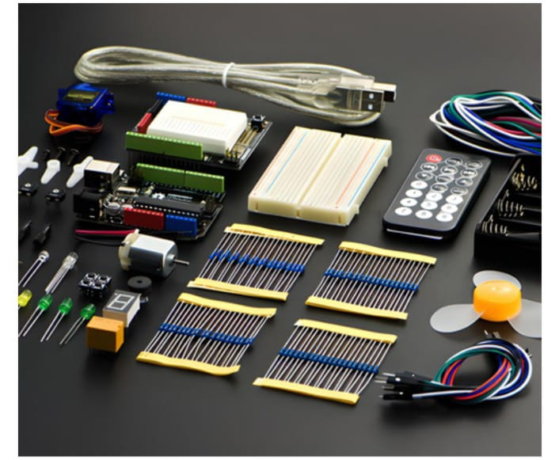

* Arduino Uno (link removed)
* LED Kit (link removed)
* Push Button Kit (link removed)
* Potentiometer Kit (link removed)
* Servo Motors (link removed)
* Buzzer (link removed)
* Soil Moisture Sensor (link removed)
* I2C LCD (link removed)
* Force Sensor (link removed)

**Coding the Arduino**

Now, let’s dive into the coding part. For coding the Arduino, Tinkercad provides us with 3 options – BLOCKS, BLOCKS+TEXT, and TEXT. In this tutorial, we will be focusing on the TEXT option i.e coding using C++.

**Conclusion**

So, we have successfully completed our first simulation project in Tinkercad. Also, if you are interested in knowing about the hardware implementation of blinking an LED using Arduino, you can click here. Hope that this tutorial was informative and worth your time.